# Event Organizer PowerApps Sample

## Overview

The Event Creation and Management PowerApp enables event managers and other users to easily organize events like a corporate conference or trade fair. Event attendees can self-register quickly and easily, and they can sign up to receive updates about conference news, special sessions, and general information. Event managers can track registrations, check-in event participants, and access real-time statistics about event attendance.

## Device Support

Event Organizer is available in both the Tablet and Phone form factors.

### Tablet

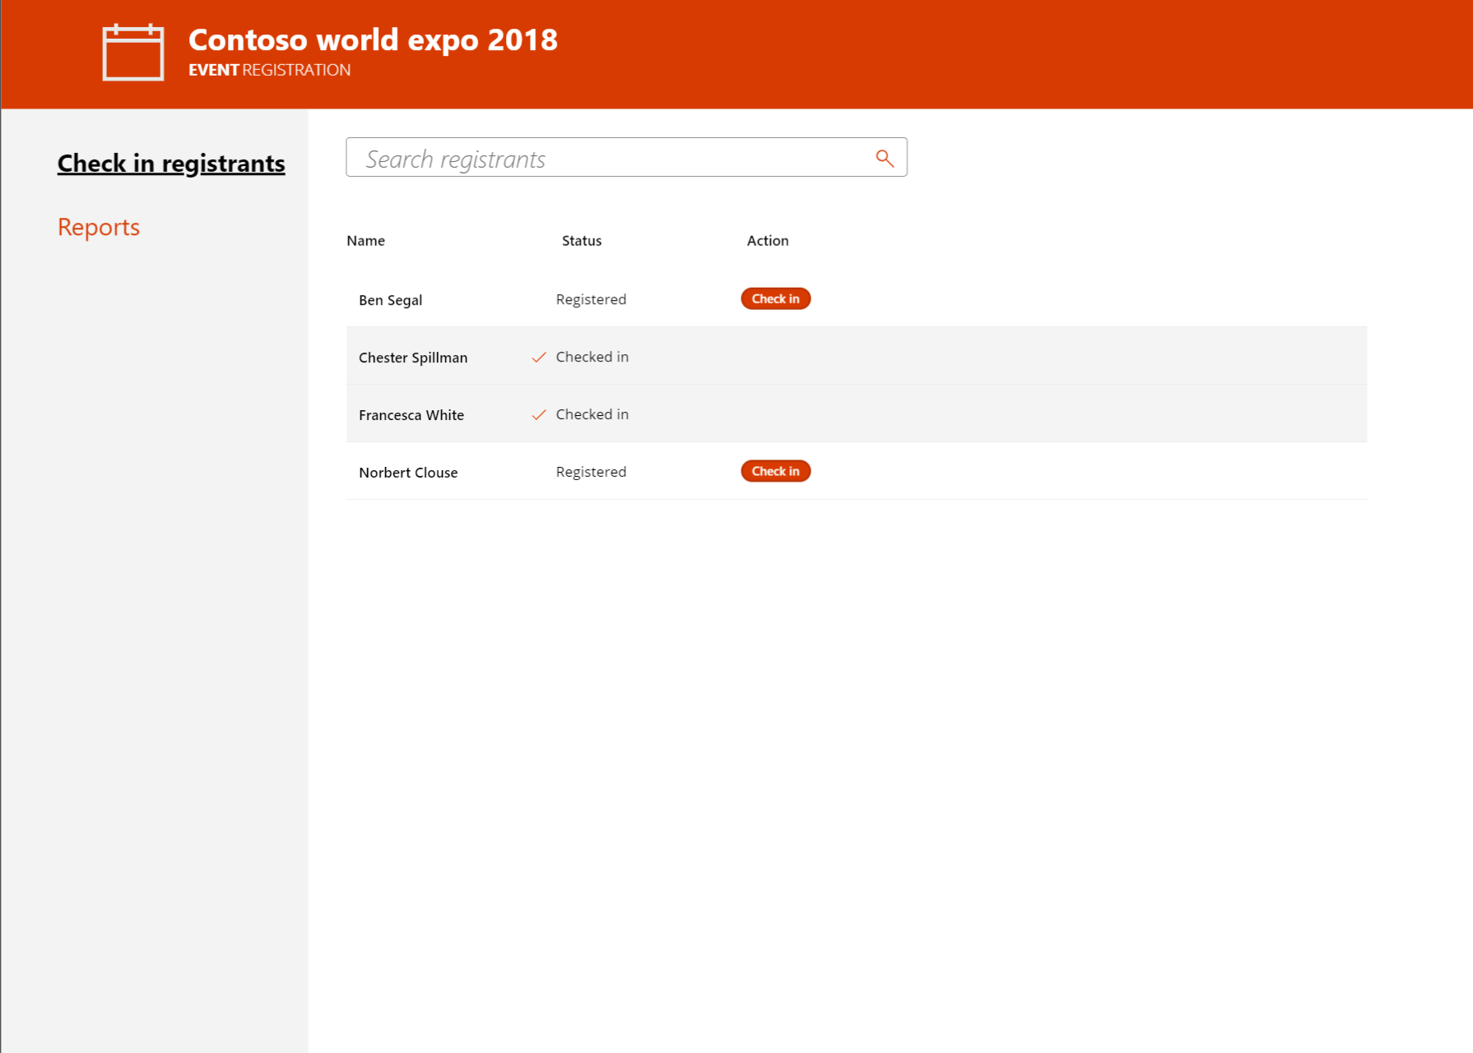

### Phone

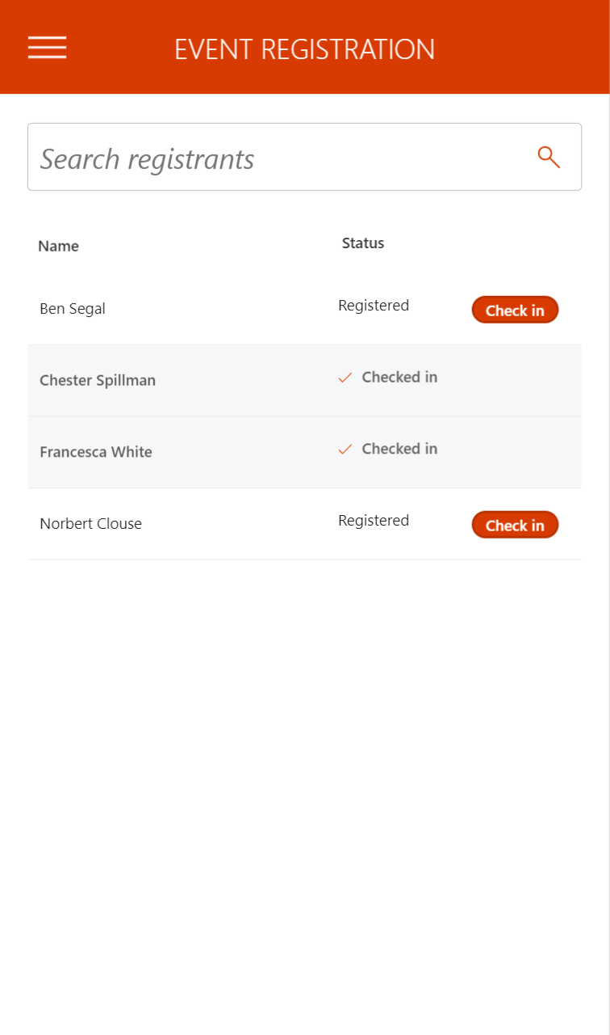

## Show me!

Watch **this video** to see an end-to-end demonstration of the functionality.

## Getting Started

See the installation instructions and **video** that describe and demonstrate how to install and set it up.

## Technical Details

### Connectors

Event Organizer uses the following Connectors to access Office 365 Services.

* [Office 365 SharePoint](https://docs.microsoft.com/en-us/connectors/sharepointonline/)

We hope you enjoy Event Organizer and look forward to hearing how you extend it for your organization!